PROJECT REPORT

SOCIAL MEDIA CAMPAIGN

|  |  |
| --- | --- |
| **DATE :** | 30 OCTOBER 2023 |
| **TEAM LEAD ID – KIRUTHI S** | CA1DB27885B25F198754C2438D755E54 |
| **TEAM MEMBER 1 - LIKITHA YASHASWINI NALAMOLU** | 8935492468062668F49432CEE16C879C |
| **TEAM MEMBER 2 - NIYATI JAIN** | 9AFCE090F5B80C884D24C848A6B9AC44 |
| **TEAM MEMBER 3 - SAHITHYA MPS** | D674C8BBDCD755FB95846E9CF3B89951 |
| **PROJECT NAME :** | SOCIAL MEDIA CAMPAIGN |

# DEFINE PROBLEM / PROBLEM UNDERSTANDING:

Create a mock Social media campaign - choose the ideal channel (FB, Insta, Linkedin, Youtube, etc)

**BRAND NAME: “THE WARDROBE”**

**CATEGORY:** Clothing Brand

**TARGET AUDIENCE:** ALL (Men, Woman, Youths, Teens, Kids)

**EMAIL ID:** [wardrobethe27@gmail.com](mailto:wardrobethe27@gmail.com)

**FACEBOOK BUSINESS PAGE:** <https://www.facebook.com/thewardrobeclothing?mibextid=ZbWKwL>

# DOCUMENTATION:

1. **CREATE A GMAIL ACCOUNT:**

Navigate to <https://www.google.com/account/about/> to get a new Gmail account.

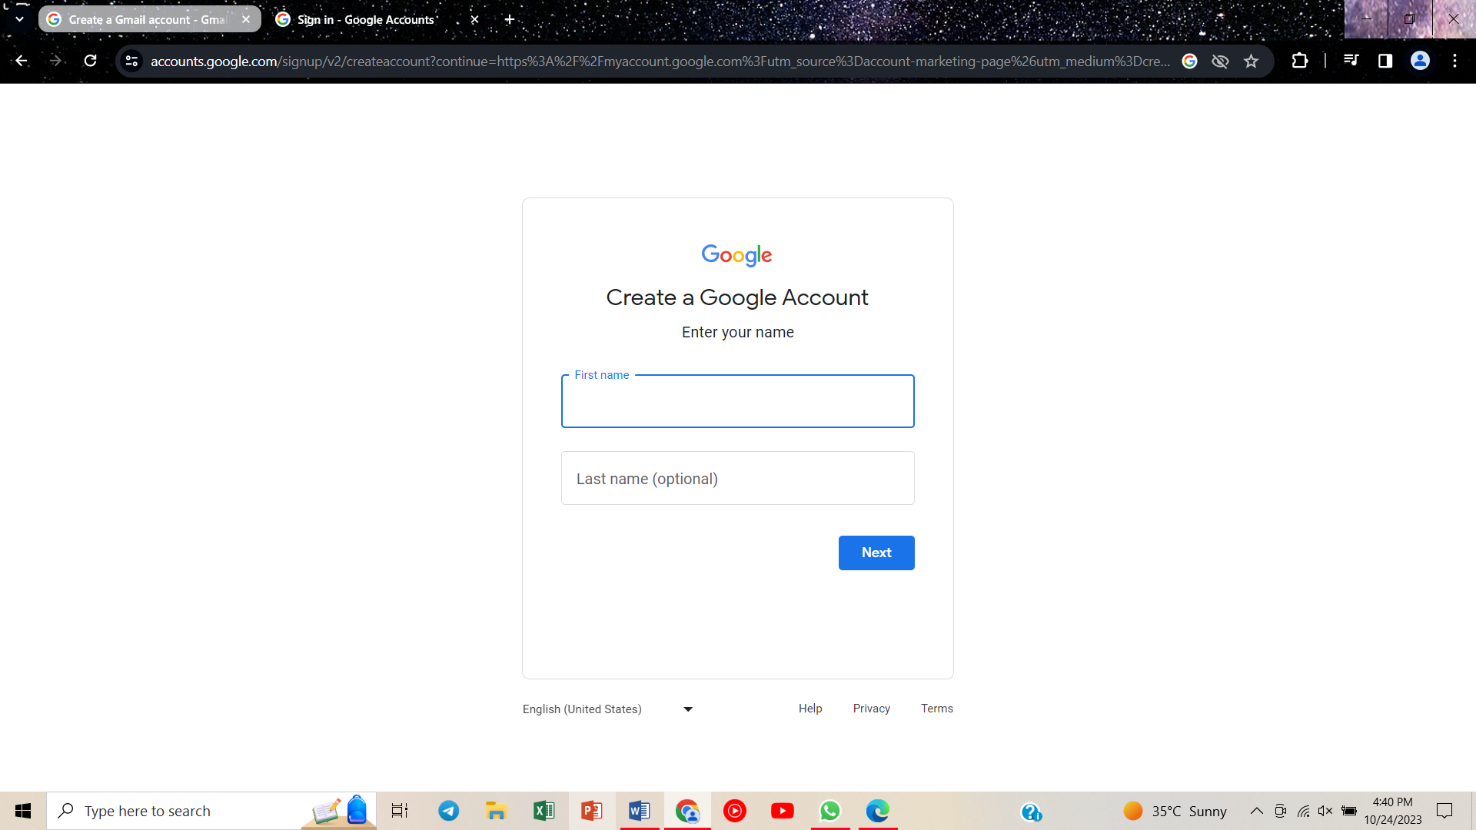

# CREATING FACEBOOK PAGE:

# Navigate to <https://www.facebook.com/home.php> to get a new Facebook page.

# C:\Users\hp\AppData\Local\Packages\5319275A.WhatsAppDesktop_cv1g1gvanyjgm\TempState\661B1E76B95CC50A7A11A85619A67D95\WhatsApp Image 2023-10-24 at 16.48.53_151879fa.jpg C:\Users\hp\AppData\Local\Packages\5319275A.WhatsAppDesktop_cv1g1gvanyjgm\TempState\C8512D142A2D849725F31A9A7A361AB9\WhatsApp Image 2023-10-24 at 16.46.55_c46fb27a.jpg

1. **CREATING POSTERS USING CANVA:**

**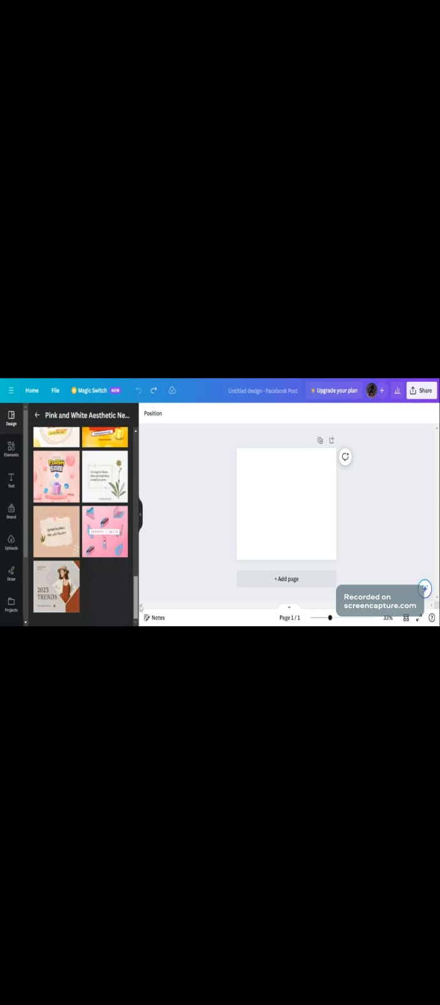**

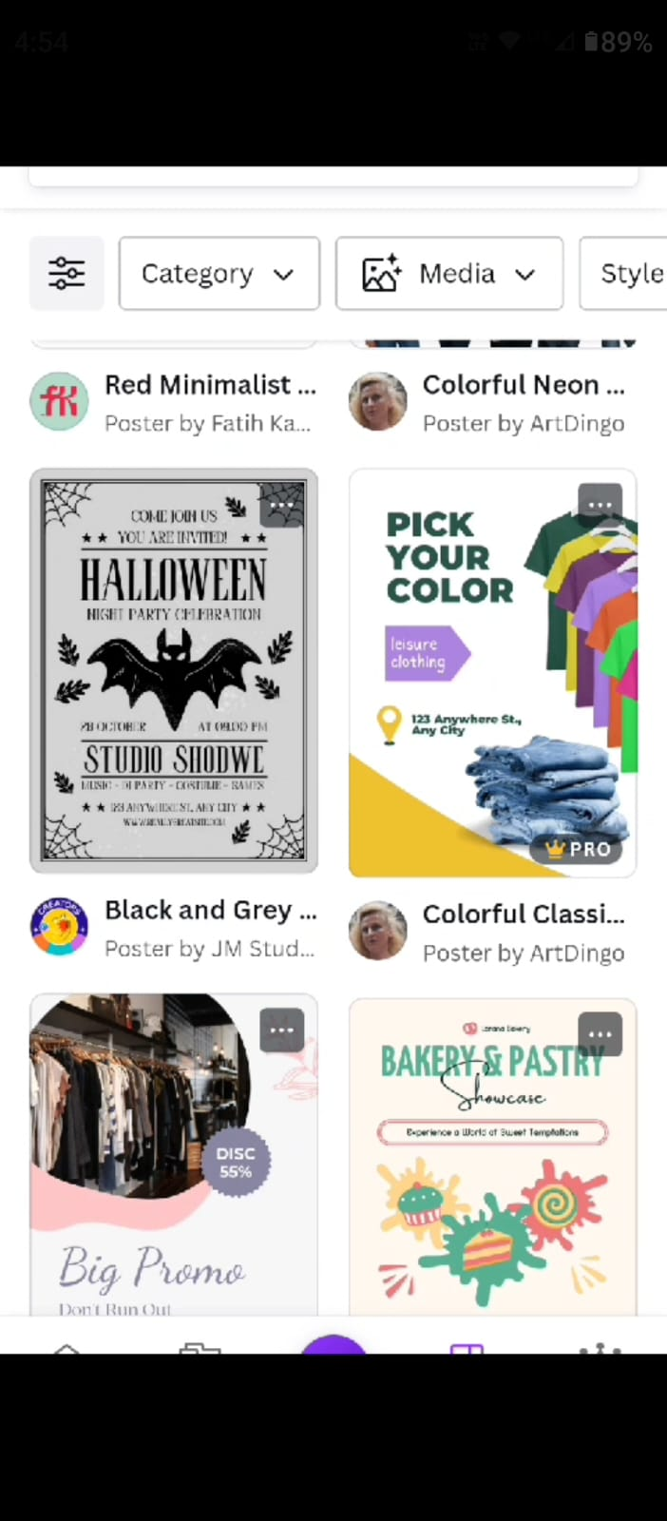

1. **UPLOADING THESE POSTERS ON THE FACEBOOK PAGE:**

**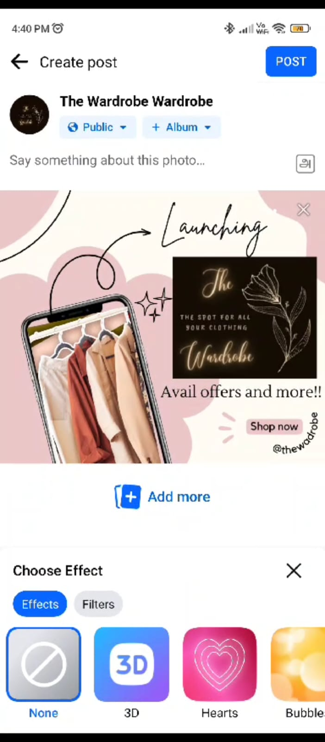 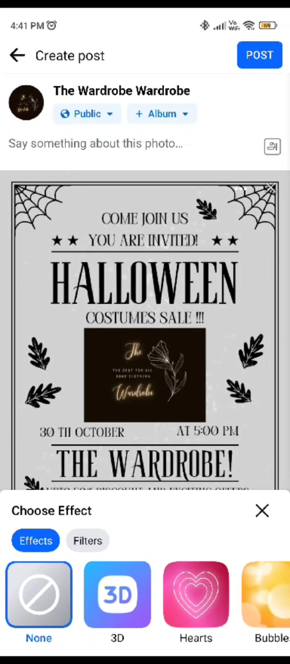**

1. **PUBLISHED POSTERS ARE VISIBLE ON THE FACEBAOOK PAGE:**

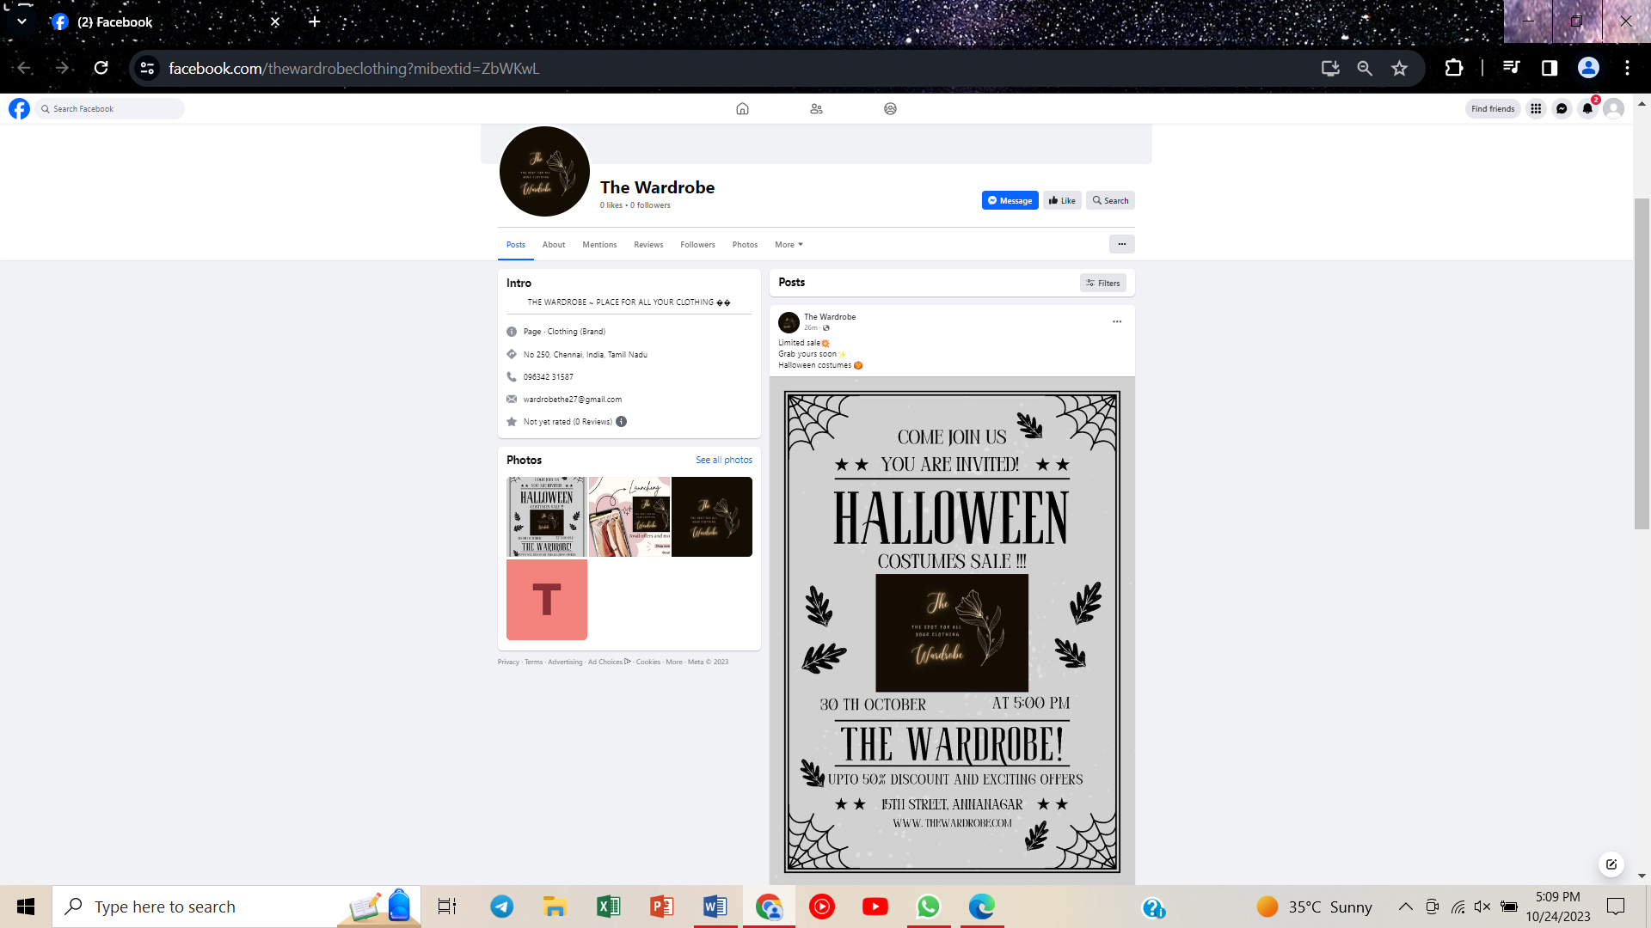

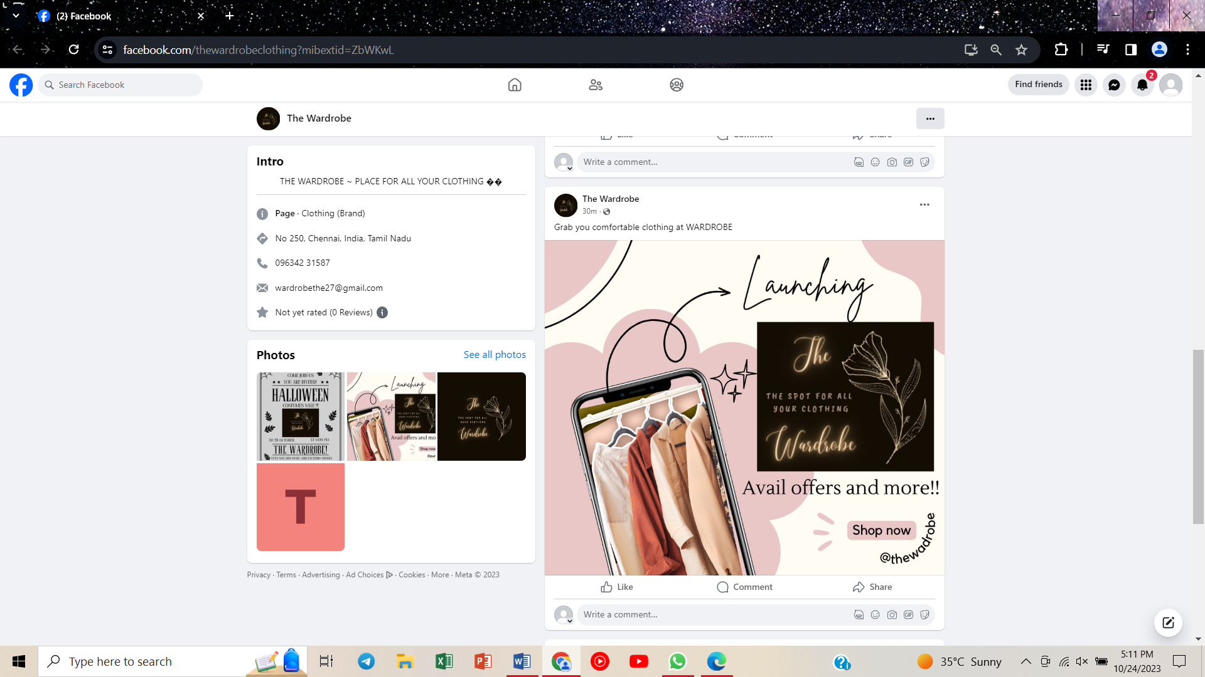

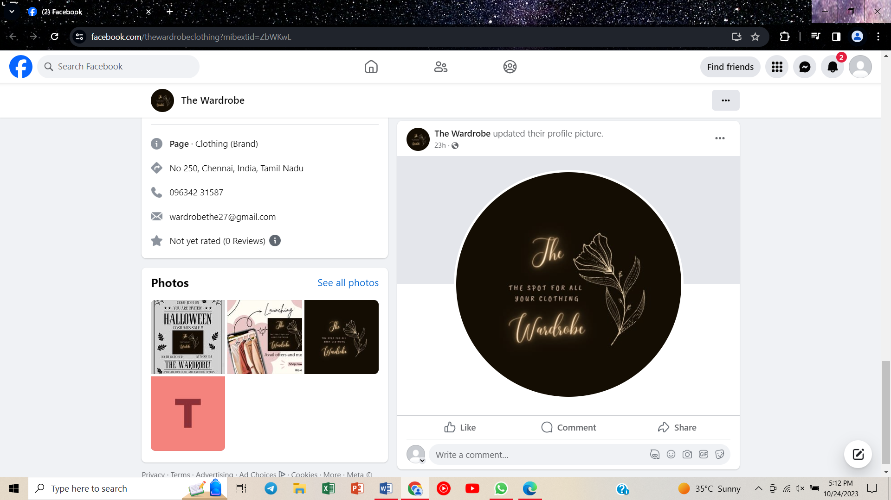

**POSTERS DESIGNED:**

****

****

**BRAND NAME:** “THE WARDROBE”

**CATEGORY:** Clothing Brand

**TARGET AUDIENCE:** ALL (Men, Woman, Youths, Teens, Kids)

**EMAIL ID:** [wardrobethe27@gmail.com](mailto:wardrobethe27@gmail.com)

**FACEBOOK BUSINESS PAGE:** <https://www.facebook.com/thewardrobeclothing?mibextid=ZbWKwL>

**GitHub LINK:**

<https://github.com/WARDROBETHE/Social-media-campaign/tree/main>

**RECORDED VIDEO DRIVE LINK:** <https://drive.google.com/file/d/1W_VOnh2489TucxtBfwM64P-DD01-hRDt/view?usp=sharing>